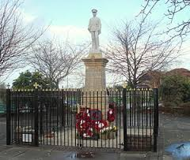

**Welcome to the latest Parish Council Newsletter.**

Firstly, I would like to invite you to our COMMUNITY ENGAGEMENT EVENING which is being held at MOULTON ROYAL BRITISH LEGION ON TUESDAY 20 JANUARY 2015, BETWEEN 7PM and 9PM. This evening will give us the opportunity to update you on several of the issues currently occupying the Parish Council - the Moulton Neighbourhood Plan; the planned improvements to the Weaver Road Play Area; the installation of CCTV Equipment at the Playing Fields/War Memorial/Car Park. Your feedback on all of these issues will be most welcome, as will any comments you may have relating to other matters of interest/concern.

The Outline Planning Permission granted for developments off Beehive Lane and Jack Lane remain a hot topic and we can assure you that the Parish Council will make appropriate representations to Cheshire West and Chester Council, ensuring that your views are made clear.

Since the last Newsletter the Parish Council has created a Special Projects Working Group that is tasked with taking forward various schemes that will be of benefit to the village. This Group is proving most beneficial in progressing ideas that will enhance our village.

Our new style Web Site has recently been launched. There are still some updates to make, but we feel the new layout is more user friendly and modern looking. Why not take a look – www.moultonpc.org.uk.

Lastly, Best Wishes from all of us at the Parish Council. Have a great Christmas and a peaceful and prosperous New Year.

Best wishes.

Cllr. Allan Aston

Chairman

=============================================================

**NEIGHBOURHOOD PLAN UPDATE**

**Our Neighbourhood Plan is now at the Second Draft Stage and is currently being reviewed by an Independent Planning Consultant who specialises in Local Planning. The next stage will be to again consult every household in the village – we will be actively seeking your comments on the contents of the Plan, which is designed to be a “Document for the People, by the People”. The Neighbourhood Plan is your chance to shape the future of your village.**

**=====================================================================================**

**CHRISTMAS TREE LIGHTS SWITCH ON**

Following the undoubted success of last years’ Event, the same format will be followed this year. The Date for your Diaries is Friday 5 December 2014 at 5pm. After the lights have been switched on the School Choir will again serenade us with a variety of Carols and Christmas Songs. Mince Pies will be on offer to all attendees. Please come along and support this excellent community initiative.

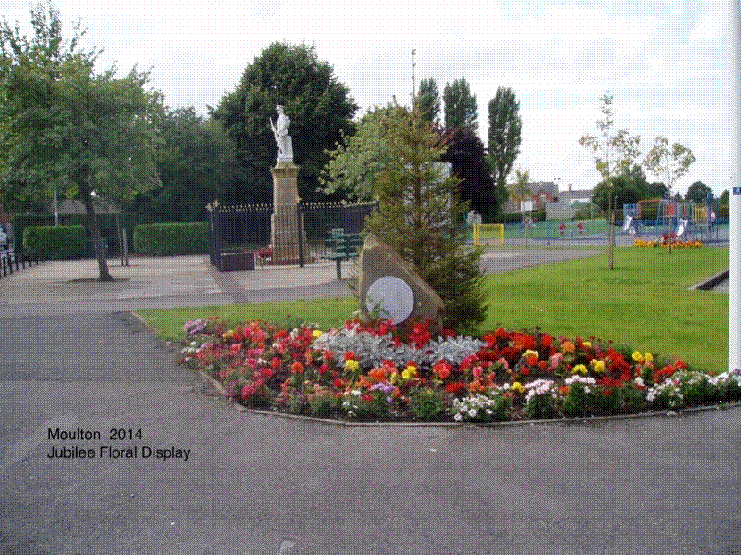 **MOULTON WINS AN AWARD!**

Cheshire Community Action awarded Moulton Parish Council a commendation for the quality of the floral display adjacent to the War Memorial. Needless to say we are delighted to receive this prestigious award on behalf of the village. We also received some positive feedback from the Best Kept Village judges who felt that the village looked tidier than in past years. Let’s all work together to improve things further – we all feel the benefit.

========================================================

**MOULTON PC – SPECIAL PROJECTS WORKING GROUP**

Initial focus is on the purchase and installation of CCTV Equipment for the War Memorial, Car Park and Playing Field area. The total cost will be in the region of £5,000 and will be covered by the Parish Council and Moulton Children’s Playing Field Trust.

The last year has, regrettably, seen an increase in the number of instances of anti-social behaviour and drug related activity in the centre of the village. The installation of state of the art equipment will act as a deterrent. Put simply, “behave in an improper, unacceptable manner and you will be caught on camera”.

The Group is also looking at creating a Community Resilience Plan. This will detail key contact points should a major incident happen within the village. More details will be released once the Plan is in place.

During 2015 the Group will consider the possibility of creating a “Heritage Walk” within the village boundaries. This will give walkers/visitors the opportunity to learn about the history of our village dating back to stone-age times.

**===================================================**

**WEAVER ROAD PLAY AREA**

Sadly, progress has been far from swift in taking this project forward – legal issues have taken up considerable time. However, the documentation is now progressing and we hope to have a Lease in place in the next 2/3 months.

Our plan is to create a quiet area that will enable you to have somewhere to stop and relax whilst out walking in the village.

Moulton School have agreed to help us set up a wildflower/wildlife section and this promises to be a wonderful addition to the project. We are also exploring the possibility of setting up a Community Book Swop Facility.

In keeping with the community theme of this project, we will be looking for volunteers to help with some of the initial landscaping work. If you can lend a hand please let Phil Sanders know (contact details are on page 4).

============================================================================================

**MOULTON CREST**

**Did you know that Moulton has a Crest? The Parish Council is keen to increase use of the Badge which depicts the Local Countryside, the River Weaver and a Bag of Salt. Our Letter Headings now incorporate the Badge.**

**BEST KEPT GARDEN PRIZE 2014**

C:\Documents and Settings\Administrator\Local Settings\Temporary Internet Files\Content.IE5\RQYLVPH5\MC900215961[1].wmfOnce again, we were very impressed with the overall quality of gardens around the village. The fine summer obviously encouraged those of you with green fingers! Cheshire West Councillor Helen Weltman undertook the final judging in early August and the results will be published later in the year, with the Prize Winners invited to attend the December Parish Council Meeting on Monday 8 December 2014.

=====================================================================================

**C:\Documents and Settings\Administrator\Local Settings\Temporary Internet Files\Content.IE5\NZMXGSC8\MC900053209[1].wmfCROW FAIR 2014**

Once again the Crow Fair, and Big Gig, were a huge success and demonstrated the community spirit that abounds here in the village. A huge thank you to those involved in organising the day – once again you excelled yourselves!

**========================================================================**

**MOULTON PHOTOGRAPHY COMPETITION 2014**

Whilst entry levels were not high, the quality certainly was.

Below is a selection of the entries received. Whilst plans to create a charity calendar have been put on hold for 12 months, the winning entry – yet to be decided – will receive a prize and will be included within the finalised Neighbourhood Plan document.

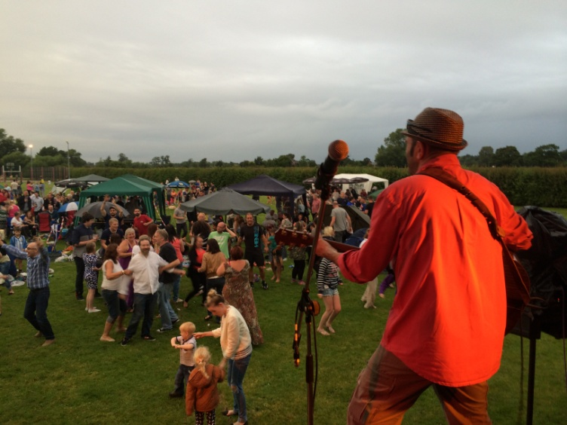 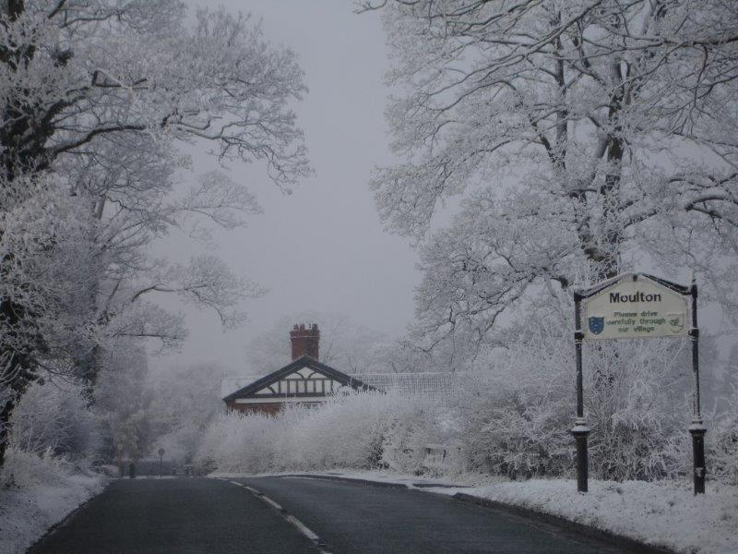

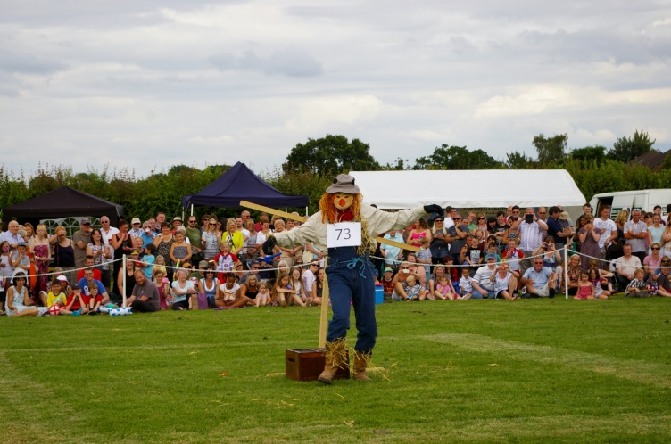 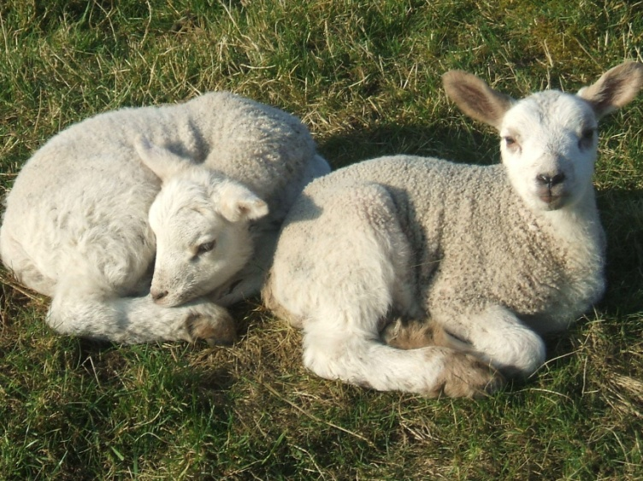

**GOT AN IDEA TO MAKE MOULTON A BETTER PLACE?**

**Then please let us know! We are always looking for ways to improve our Community and welcome any ideas you may have. Don’t be shy to come forward. Contact details are at the foot of the page.**

**===================================================================================== PARISH COUNCIL ELECTIONS – MAY 2015**

**May 2015 will see Elections held for the 9 seats that make up Moulton Parish Council. If you are interested in seeking nomination and would like more information on what the role entails please contact any of the Councillors listed below, or the Parish Clerk, for an informal, confidential chat.**

**========================================================================**

**I’VE GOT A PROBLEM ...... WHO DO I CONTACT?**

To speak to the right person at the right time please note the following:-

* For an emergency requiring rapid response from the Police, Ambulance Service or Fire Brigade ........ 🕾 **999**.
* For Police support in a non-emergency situation, e.g. stolen vehicles/damaged property/minor traffic issues/to report drug activity ....... 🕾 **101**.
* For Highways Issues requiring attention, e.g. potholes/street lamps not working/uneven pavements/uncut hedges that limit viewing; Refuse Collection Issues; Off Road Footpath Issues, e.g. overgrown verges/obstructions ...... 🕾 **0300 123 8 123**, 🖱**enquiries@cheshirewestandchester.gov.uk**, or report via **www.cheshirewestandchester.org.uk** (see homepage for links to specific report pages).
* For Moulton Playing Field issues requiring prompt attention, e.g. broken equipment, glass on the floor ..... 🕾 **07908 031367**.

**=====================================================================================**

**HOW DO I CONTACT THE PARISH COUNCIL?**

There are several ways, all of them very easy to do:-

Firstly, why not come and meet us at a Parish Council Meeting – every 2nd Monday in the Month (except August) at the Village Hall, commencing at 7.45pm. Time is always set aside for Public Questions at the start of the Meetings.

Alternatively, you can contact any of the Councillors/Officials listed below:-

|  |  |  |
| --- | --- | --- |
| NAME | ADDRESS | E-MAIL ADDRESS |
| Cllr. Allan Aston (Chairman) | 8 Barlow Road | aaston@moultonpc.org.uk |
| Cllr. Nick Harris (Vice Chairman) | 81 Gladstone Street, Winsford | nharris@moultonpc.org.uk |
| Cllr. Chris Bowie | 69 Niddries Lane | cbowie@moultonpc.org.uk |
| Cllr. Allan Burgess | 9 Main Road | aburgess@moultonpc.org.uk |
| Cllr. Jim Clark | 8 Harvest Close | jclark@moultonpc.org.uk |
| Cllr. Pauline Vernon | 30 Main Road |  |
| Cllr. Denise Watkinson | 37 Eaton View | dwatkinson@moultonpc.org.uk |
| Cllr. Arthur Wood | 489 London Road, Davenham | awood@moultonpc.org.uk |
| Phil Sanders (Parish Clerk) | 21 Linnet Close, Winsford | clerk@moultonpc.org.uk  Tel – 07908 031367 (Calls only please. No Text messages) |

Why not visit our Facebook page for the latest news www.facebook.com/MoultonParishCouncil

©Moulton Parish Council – November 2014